Using **virtualenv**

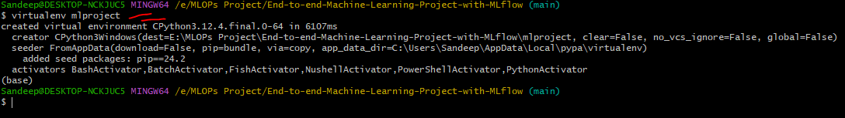

**Activate** virtual environment

1st way

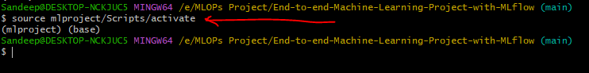

2nd way (you can use any one method)



**Deactivate** virtual environment

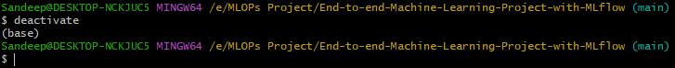

To **clear** screen



Using **conda**

To create virtual environment

conda create --name myenv

conda create -n myenv

conda create -p myenv

conda create --prefix myenv

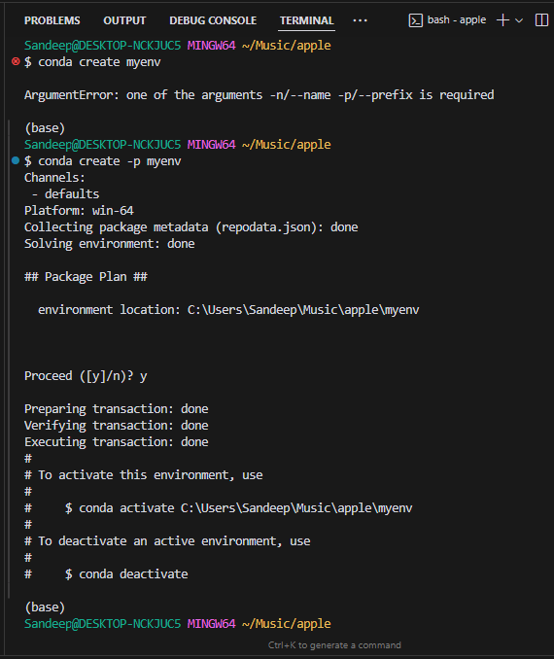

To check the list of existing conda virtual environments

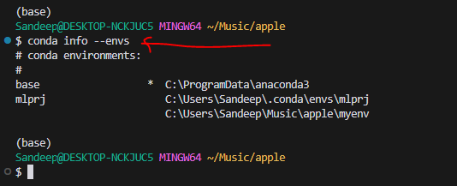

To activate myenv

1st way

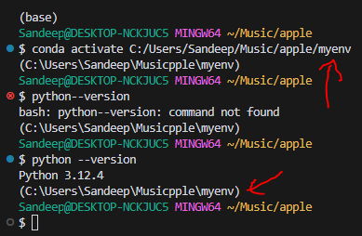

2nd way

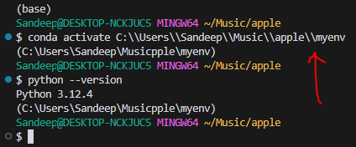

To deactivate myenv

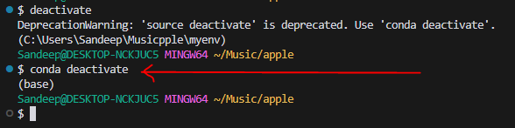

Note:

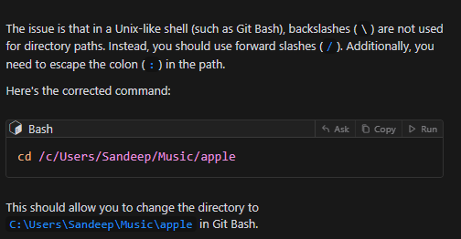

**Project Set Up (inside virtual environment)**

Before running **template.py**

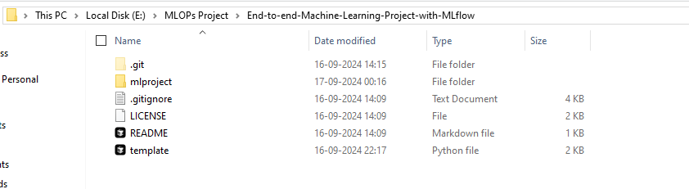

Then running python command to run **template.py**

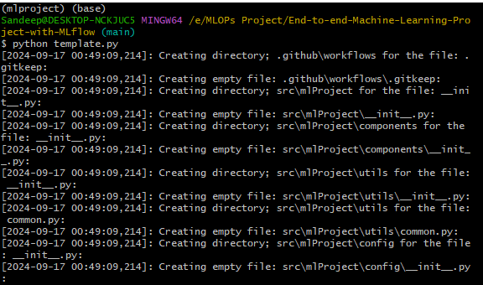

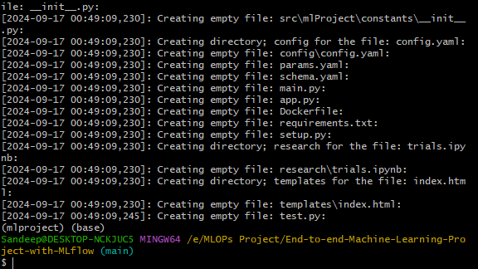

After successfully running **template.py**

